**Class Practice - 4**

**MIS 64038**

1. Plot the following graph (adding smooth()):

ggplot(cars, aes(x=displ, y = cty)) + geom_point(colour="green") + geom_smooth()

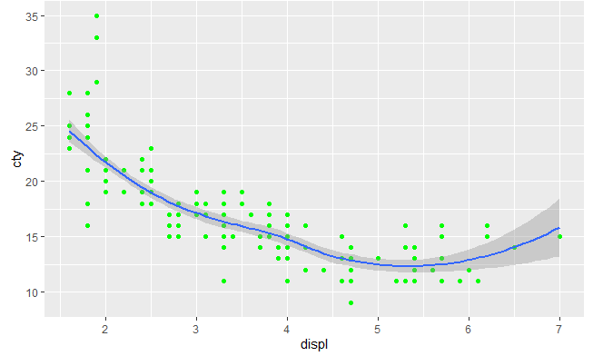

1. Change the method to linear (method=”lm”)

ggplot(cars, aes(x=displ, y = cty)) + geom_point(colour="green") +

geom_smooth(**method = "lm**")

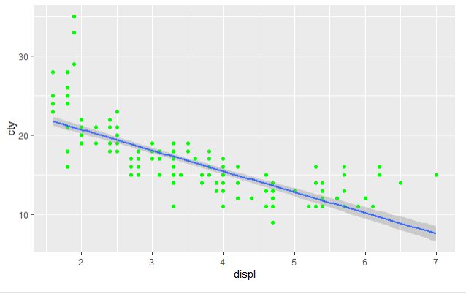

1. Changing the span parameter to control wiggliness of the line:

ggplot(cars, aes(x=displ, y = cty)) + geom_point(colour="red") + geom_smooth(span=0.4)

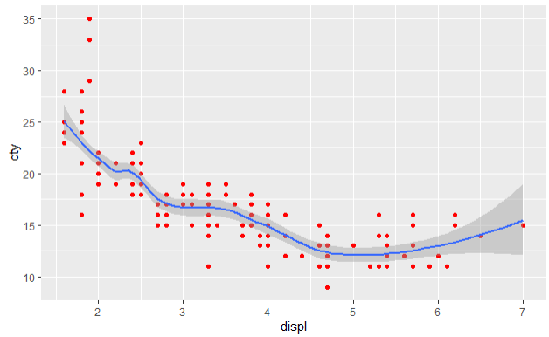

1. How is this smooth() function useful in interpreting results?

It allows for you to track the overall pattern.

1. Can you use this to explain this to a senior management executive

As the engine displacement increases the miles per gallon in the city decreases, which means there is a negative relationship between the 2 measures.

1. Try changing span parameter, Values range from 0 to 1

Using a span of .25 you can see that the smooth line is more sensitive to variations in the data

